**Hospital Management System**

Name: Ayub raj Thapa

Dept: MCA

Major Project: Hospital Management System

**Language & Tools Used**

* Python
* Django
* HTML&CSS
* Bootstrap
* POSTGRE SQL

**Screenshots**

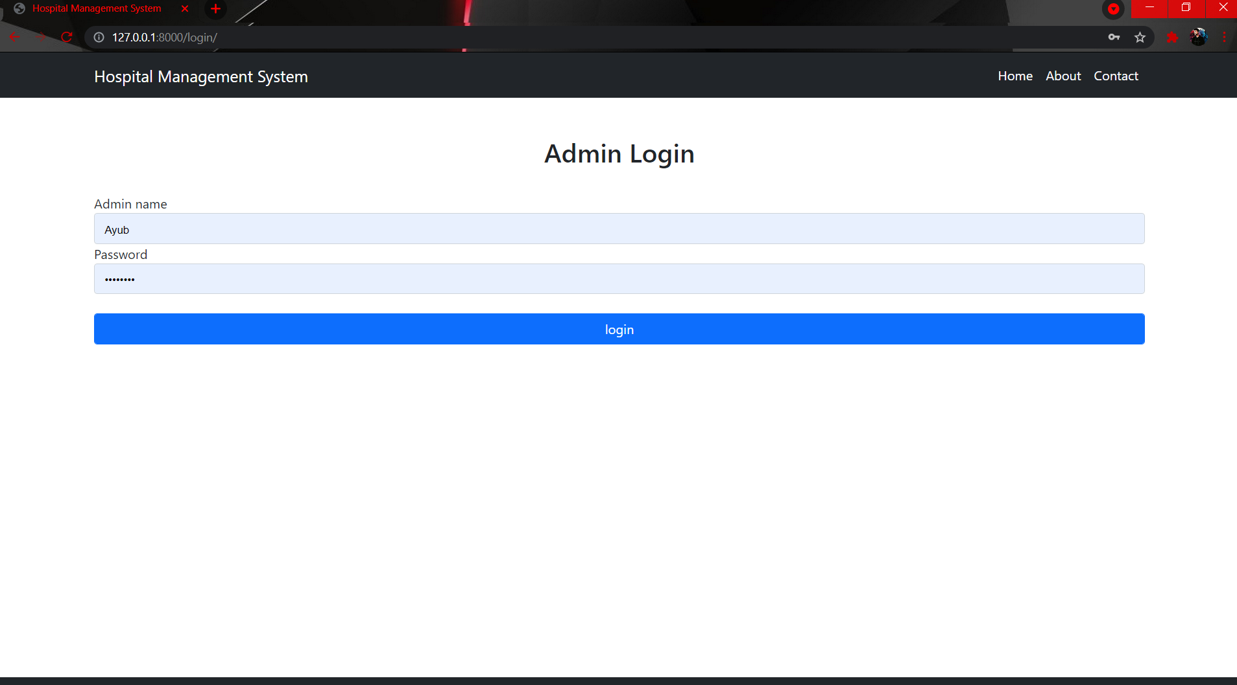

**Login panel**

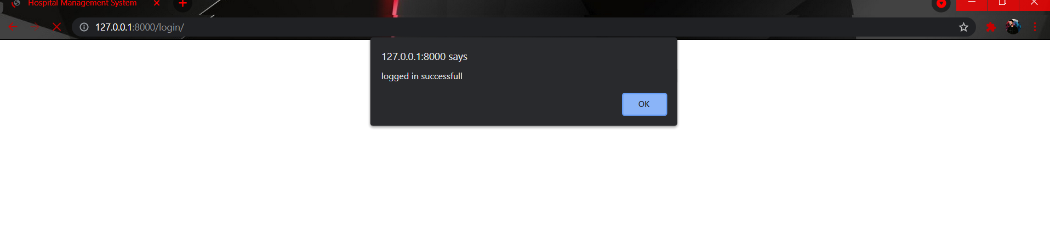

**After login**

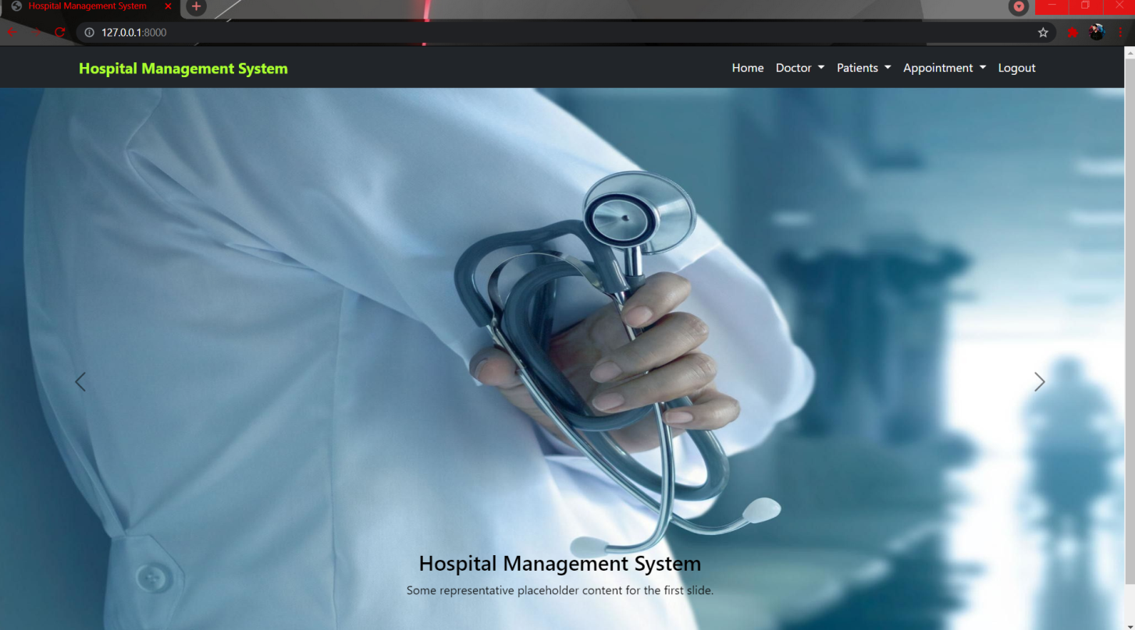

**Index (Homepage)**

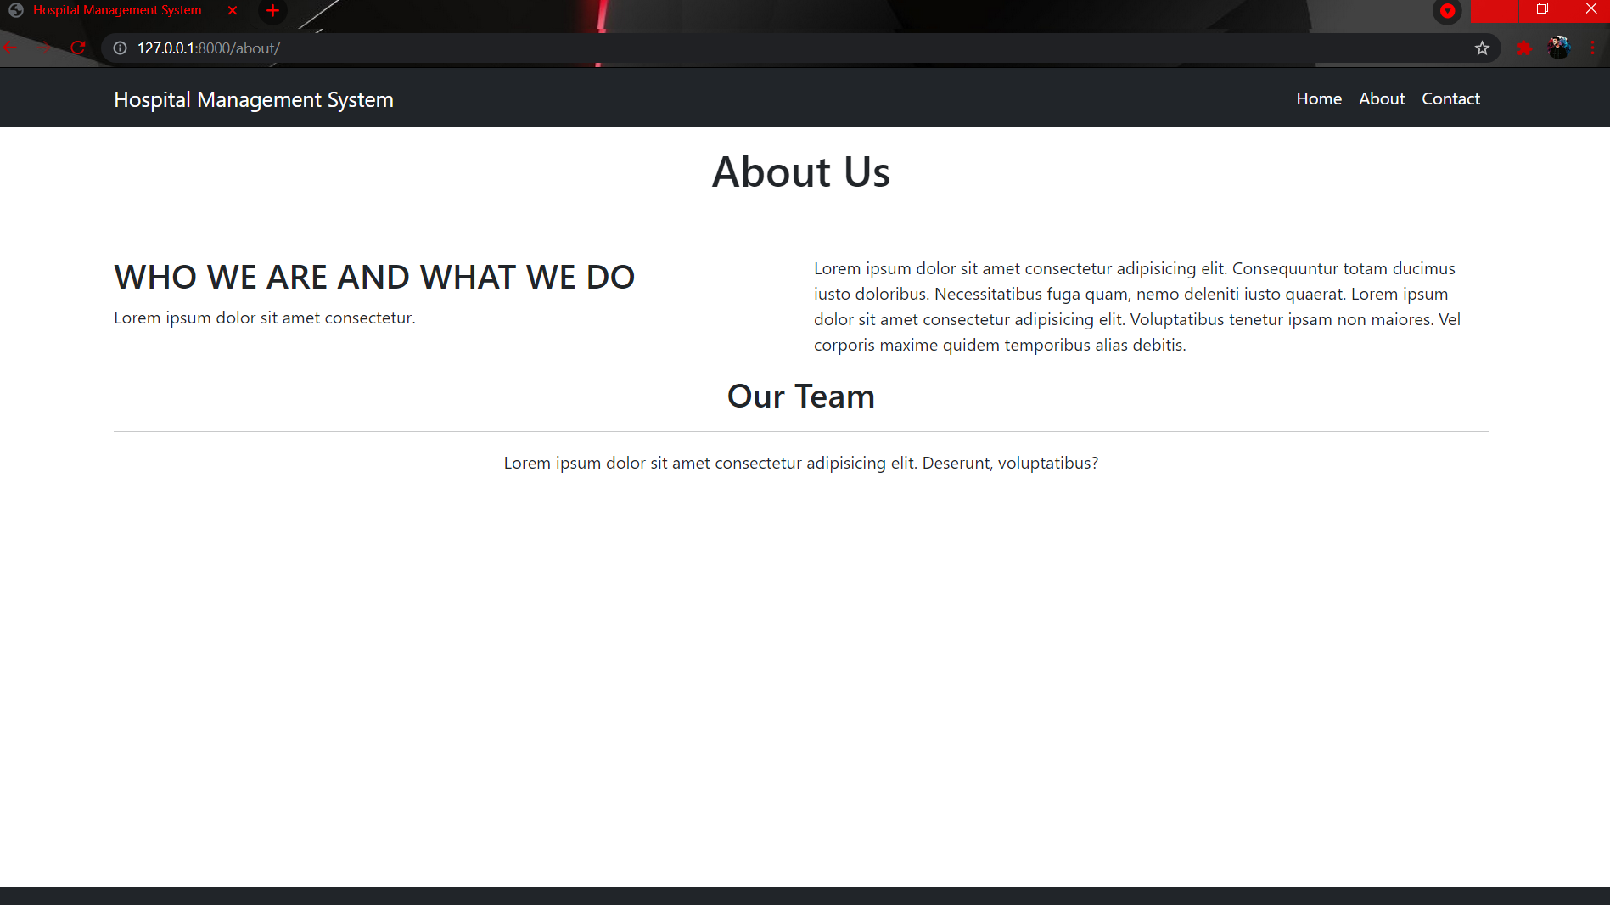

**About us**

**Models**

**Add Doctor**

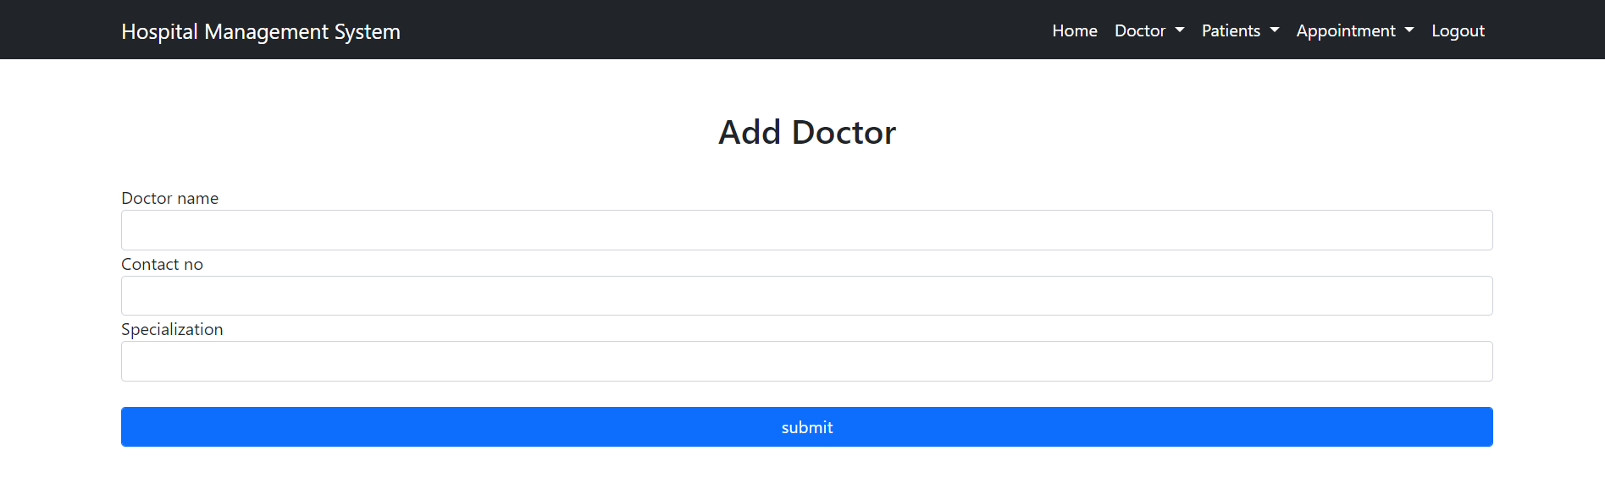

**View Doctor**

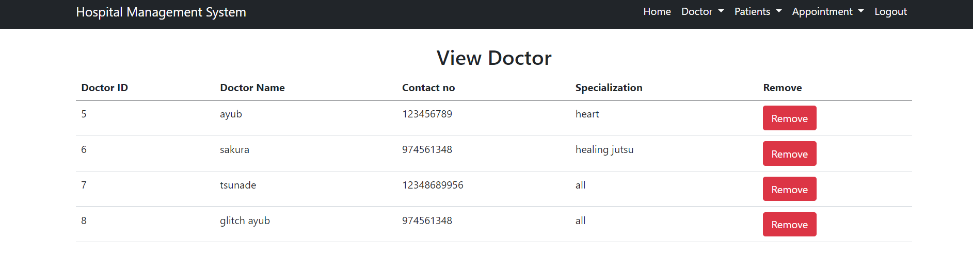

**Add Patient**

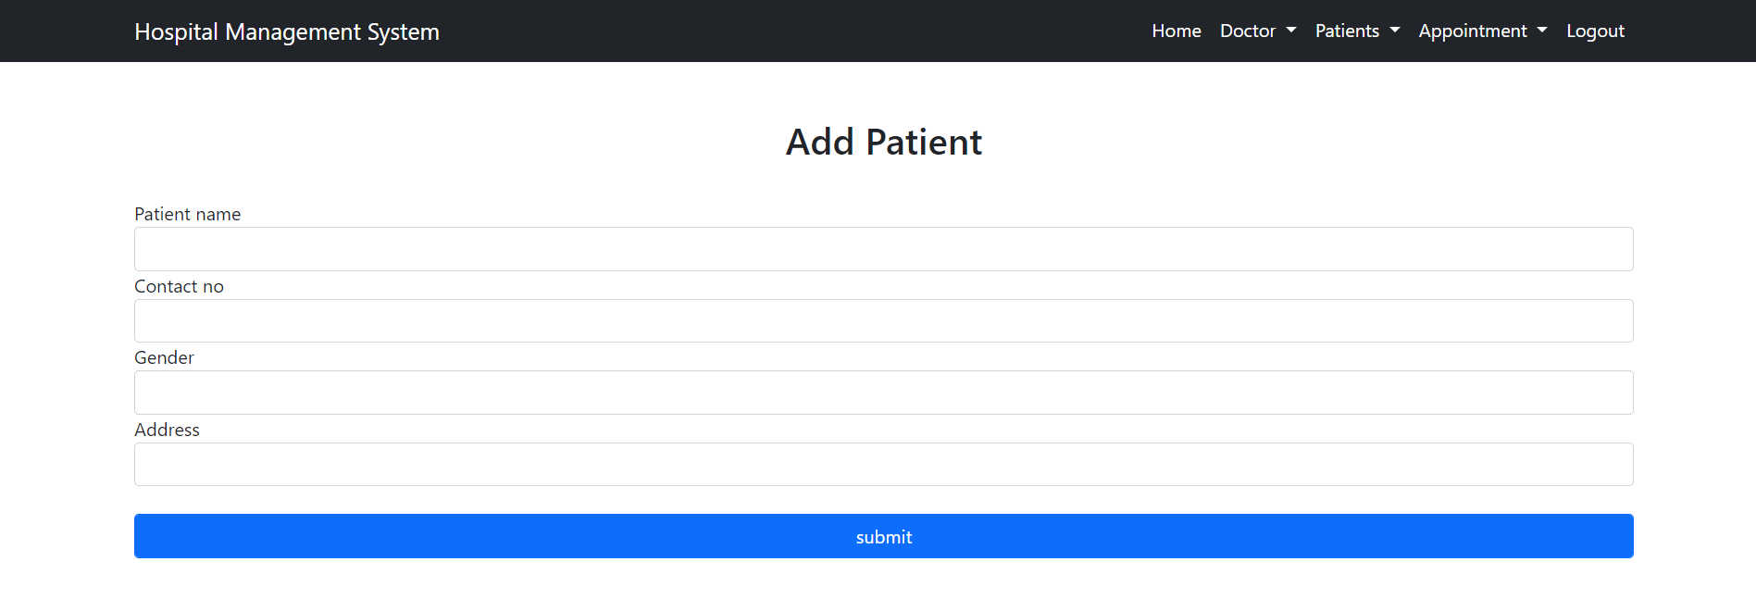

**View Patient**

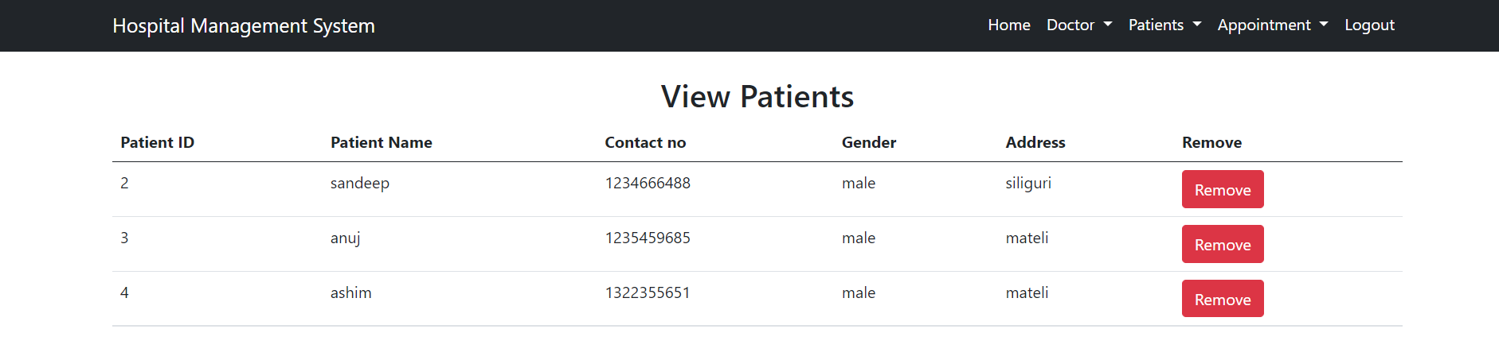

**Add Appointment**

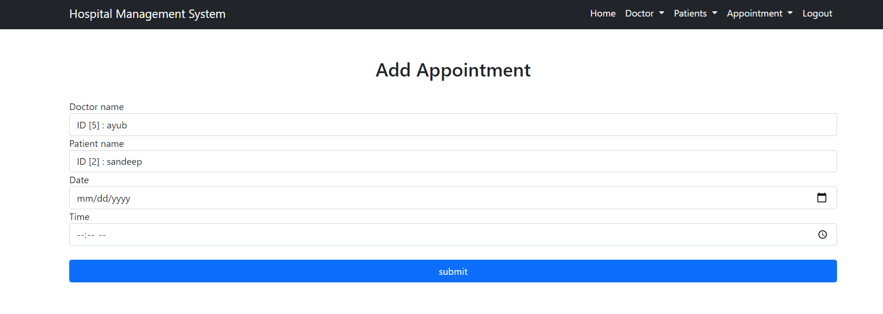

**View Appointment**

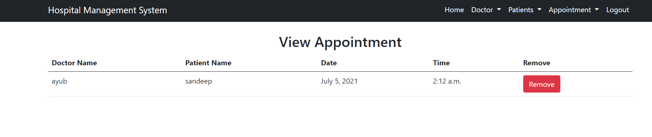

CSS

PYTHON

HTML

Bootstrap

POSTGRE SQL